***Homework-3***

1. ***Coordinates:***

|  |  |  |  |
| --- | --- | --- | --- |
| No. | Location | Longitude | Latitude |
| 1. | Home | -118.28028610000001 | 34.028357 |
| 2. | Galen | -118.27975 | 34.02127 |
| 3. | Lyon Center | -118.28831 | 34.02439 |
| 4. | SGM | -118.2890857 | 34.0210824 |
| 5. | Tommy Trojan | -118.28599229999999 | 34.0206485 |
| 6. | Doheny Memorial Library | -118.28395 | 34.02023 |
| 7. | Leavey Library | -118.28297339999999 | 34.021642299999996 |
| 8. | USC Schaeffer Center | -118.28355069999999 | 34.018926799999996 |
| 9. | Ogasawara Plaza | -118.2908054 | 34.0191909 |

2.***KML file:***

<?xml version="1.0" encoding="utf-8"?>

<kml xmlns="http://www.opengis.net/kml/2.2">

<Document>

<name>galen</name>

<visibility>0</visibility>

<open>1</open>

<Placemark>

<name>Home</name>

<Point>

<coordinates>-118.28028610000001,34.028357,0</coordinates>

</Point>

</Placemark>

<Placemark>

<name>Galen</name>

<Point>

<coordinates>-118.27975,34.02127,0</coordinates>

</Point>

</Placemark>

<Placemark>

<name>Lyon Center</name>

<Point>

<coordinates>-118.28831,34.02439,0</coordinates>

</Point>

</Placemark>

<Placemark>

<name>SGM</name>

<Point>

<coordinates>-118.2890857,34.0210824,0</coordinates>

</Point>

</Placemark>

<Placemark>

<name>Tommy Trojan</name>

<Point>

<coordinates>-118.28599229999999,34.0206485,0</coordinates>

</Point>

</Placemark>

<Placemark>

<name>Doheny Memorial Library</name>

<Point>

<coordinates>-118.28395,34.02023,0</coordinates>

</Point>

</Placemark>

<Placemark>

<name>Leavey Library</name>

<Point>

<coordinates>-118.28297339999999,34.021642299999996,0</coordinates>

</Point>

</Placemark>

<Placemark>

<name>USC Schaeffer Center</name>

<Point>

<coordinates>-118.28355069999999,34.018926799999996,0</coordinates>

</Point>

</Placemark>

<Placemark>

<name>Ogasawara Plaza</name>

<Point>

<coordinates>-118.2908054,34.0191909,0</coordinates>

</Point>

</Placemark>

</Document>

</kml>

3. ***Screenshot of the 9 coordinates in Google Earth***:

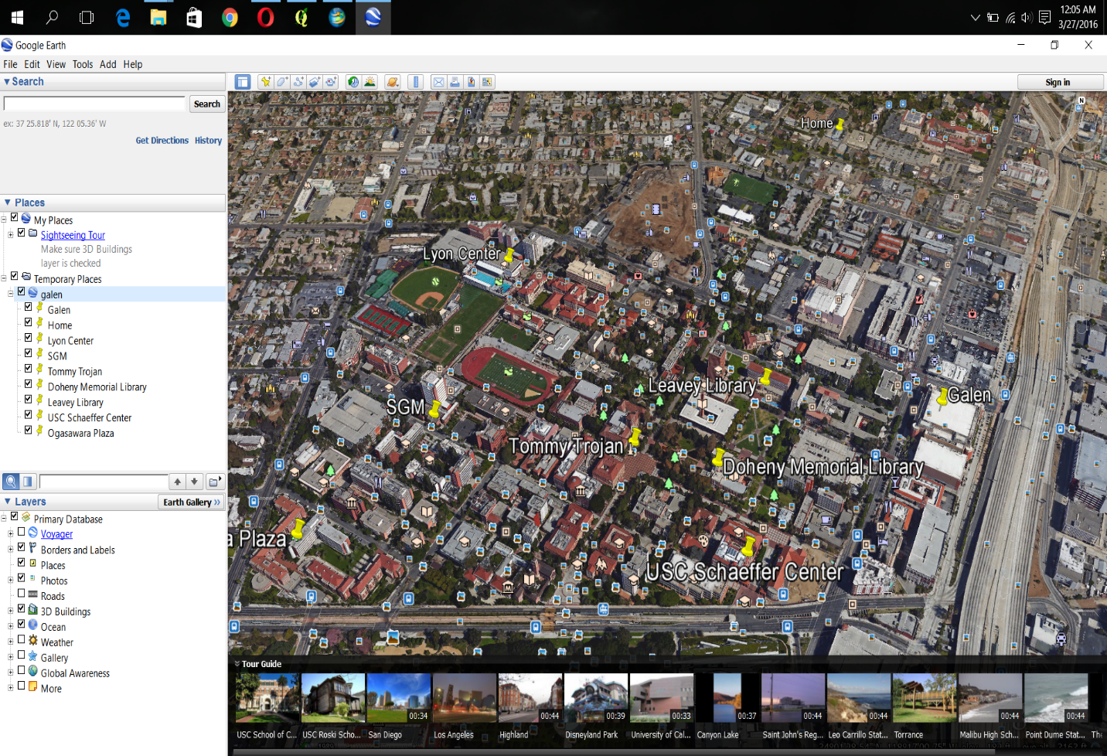

4. ***Qgis file snapshot:***

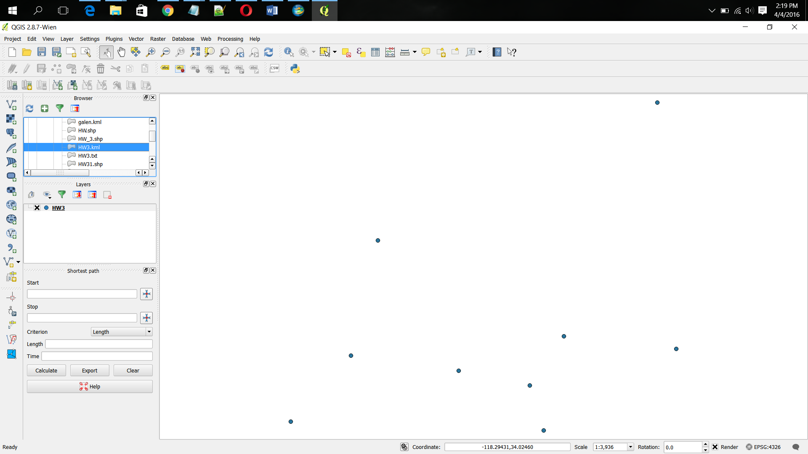

5. ***Shape file in ArcGIS Explorer***:

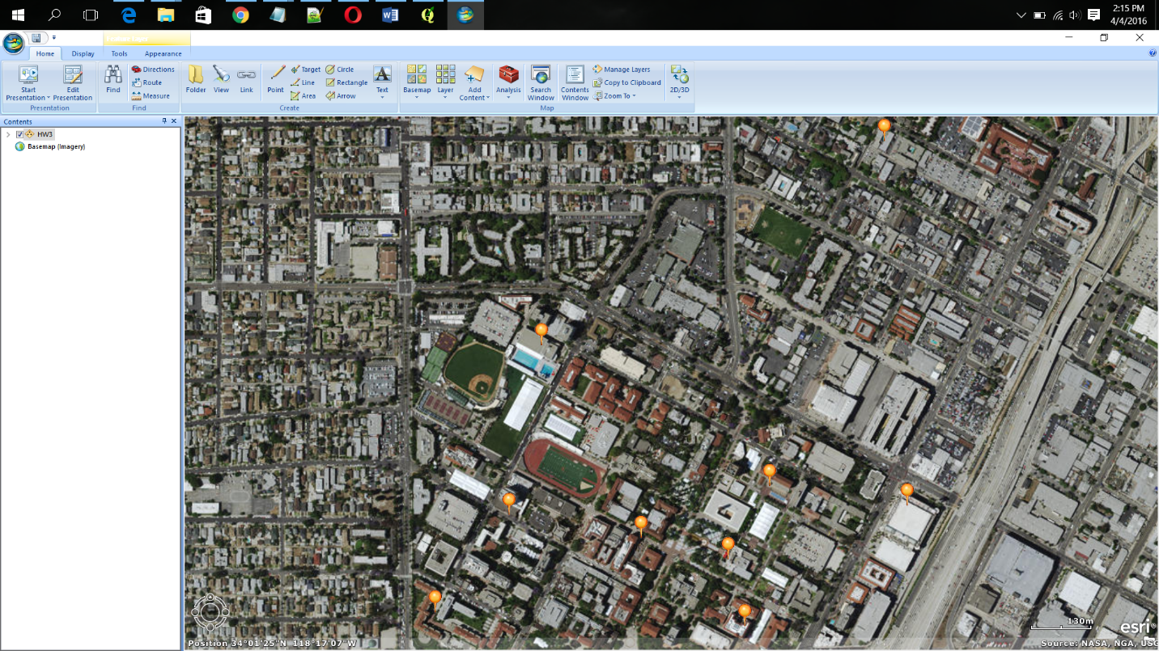

6. ***SQL QUERIES:***

Creating table for the coordinates:

create table geo(

id integer primary key,

lname varchar(50),

latitude float,

longitude float

location MDSYS.SDO_GEOMETRY);

INSERT INTO geo values (1,'Home', 34.028357, -118.28028610000001, MDSYS.SDO_GEOMETRY (2001, 8307, MDSYS.SDO_POINT_TYPE (-118.28028610000001, 34.028357, NULL), NULL, NULL));

INSERT INTO geo values (2,'Galen', 34.02127,-118.27975, MDSYS.SDO_GEOMETRY (2001, 8307, MDSYS.SDO_POINT_TYPE (-118.27975, 34.02127, NULL), NULL, NULL));

INSERT INTO geo values (3,'Lyon Center', 34.02439, -118.28831, MDSYS.SDO_GEOMETRY (2001, 8307, MDSYS.SDO_POINT_TYPE (-118.28831, 34.02439, NULL), NULL, NULL));

INSERT INTO geo values (4,'SGM', 34.0210824, -118.2890857, MDSYS.SDO_GEOMETRY (2001, 8307, MDSYS.SDO_POINT_TYPE (-118.2890857, 34.0210824, NULL), NULL, NULL));

INSERT INTO geo values (5,'Tommy Trojan', 34.0206485, -118.28599229999999, MDSYS.SDO_GEOMETRY (2001, 8307, MDSYS.SDO_POINT_TYPE (-118.28599229999999, 34.0206485, NULL), NULL, NULL));

INSERT INTO geo values (6,'Doheny Memorial Library', 34.02023, -118.28395, MDSYS.SDO_GEOMETRY (2001, 8307, MDSYS.SDO_POINT_TYPE (-118.28395, 34.02023, NULL), NULL, NULL));

INSERT INTO geo values (7,'Leavey Library', 34.021642299999996, -118.28297339999999, MDSYS.SDO_GEOMETRY (2001, 8307, MDSYS.SDO_POINT_TYPE (-118.28297339999999, 34.021642299999996, NULL), NULL, NULL));

INSERT INTO geo values (8,'USC Schaeffer Center', 34.018926799999996, -118.28355069999999, MDSYS.SDO_GEOMETRY (2001, 8307, MDSYS.SDO_POINT_TYPE (-118.28355069999999, 34.018926799999996, NULL), NULL, NULL));

INSERT INTO geo values (9,'Ogasawara Plaza', 34.0191909, -118.2908054, MDSYS.SDO_GEOMETRY (2001, 8307, MDSYS.SDO_POINT_TYPE (-118.2908054, 34.0191909, NULL), NULL, NULL));

INSERT INTO user_sdo_geom_metadata

(TABLE_NAME,

COLUMN_NAME,

DIMINFO,

SRID)

VALUES (

'geo','location',

SDO_DIM_ARRAY (

SDO_DIM_ELEMENT ('X', 0, 20, 0.005),

SDO_DIM_ELEMENT ('Y', 0, 20, 0.005)

),

8307);

CREATE INDEX geo_index on geo (location)

INDEXTYPE IS MDSYS.SPATIAL_INDEX;

SELECT SDO_AGGR_CONVEXHULL (

MDSYS.SDOAGGRTYPE (location, 0.005)) from geo;

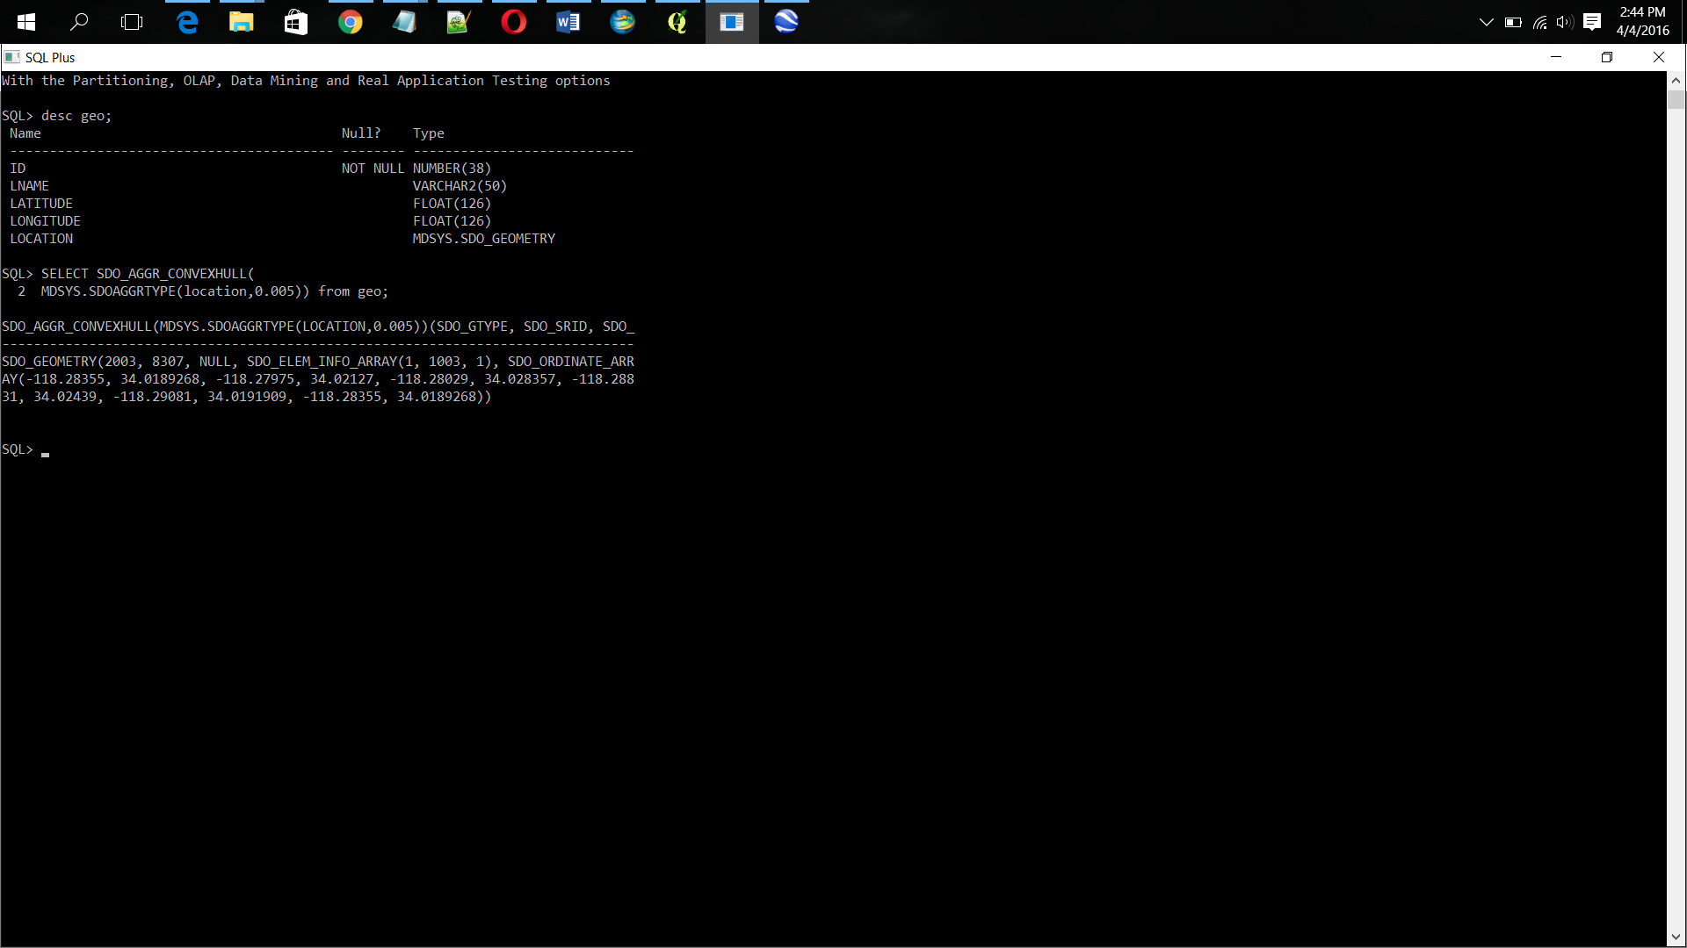

select g.lname,g.longitude,g.latitude from geo g where sdo_nn (g.location, mdsys.sdo_geometry (2001, 8307, sdo_point_type (-118.28028610000001, 34.028357, null), null, null),'sdo_num_res=4 unit=mile') ='TRUE' and G.id!= 1;

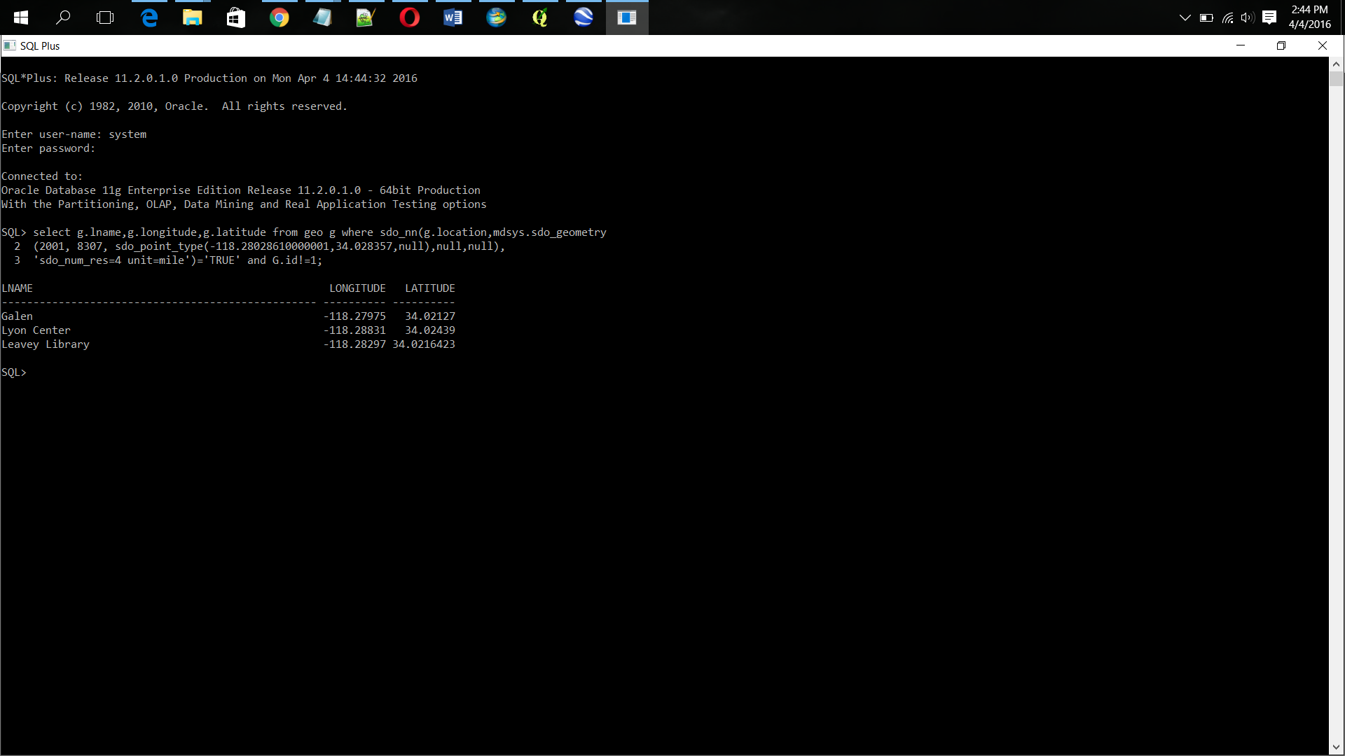

***Convex Hull:***

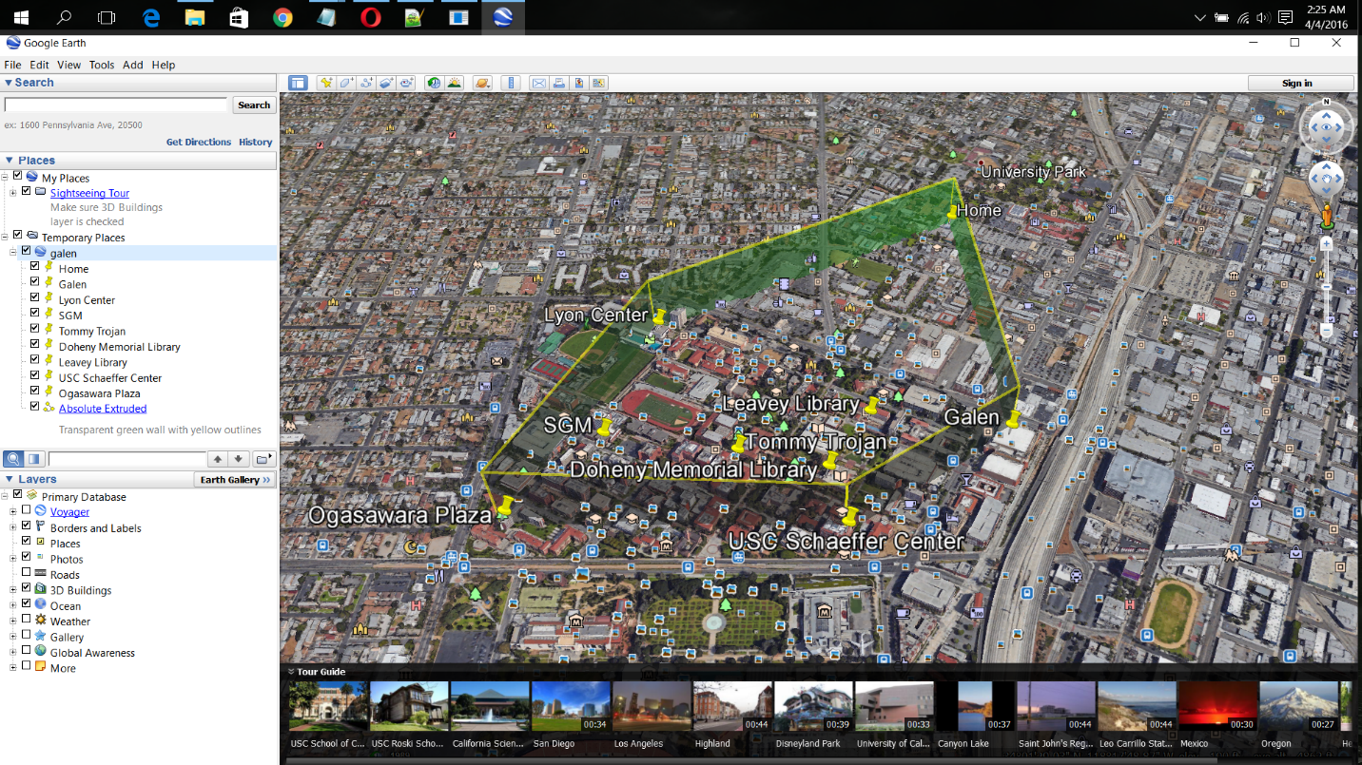

***Nearest points to Home:***

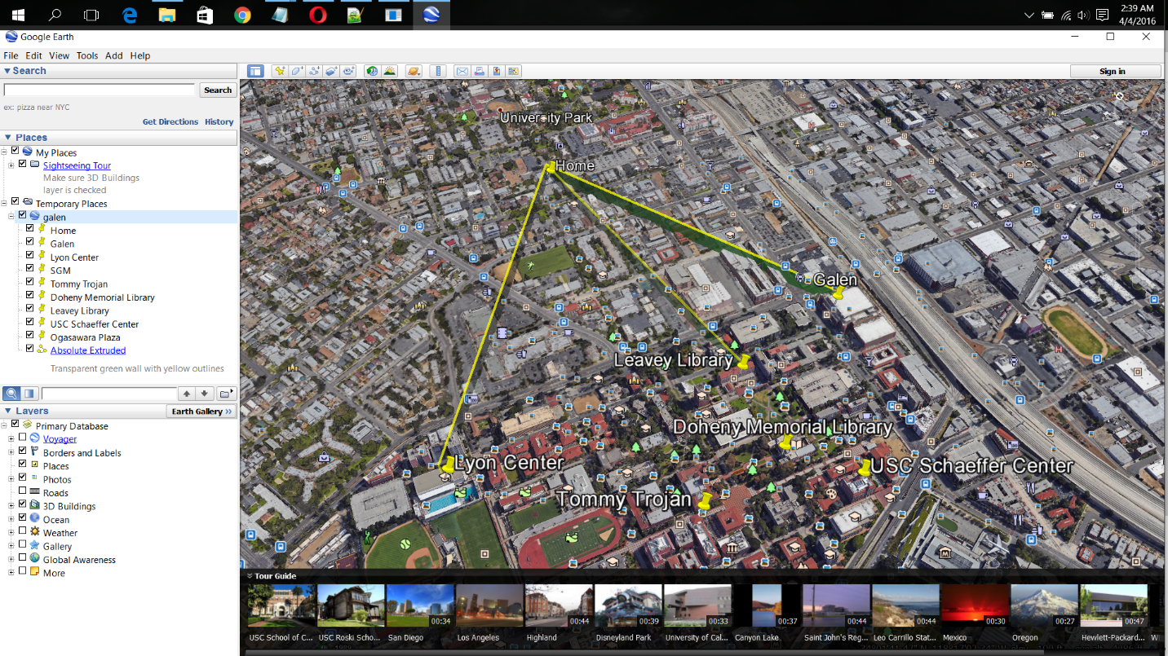

***Spirograph:***

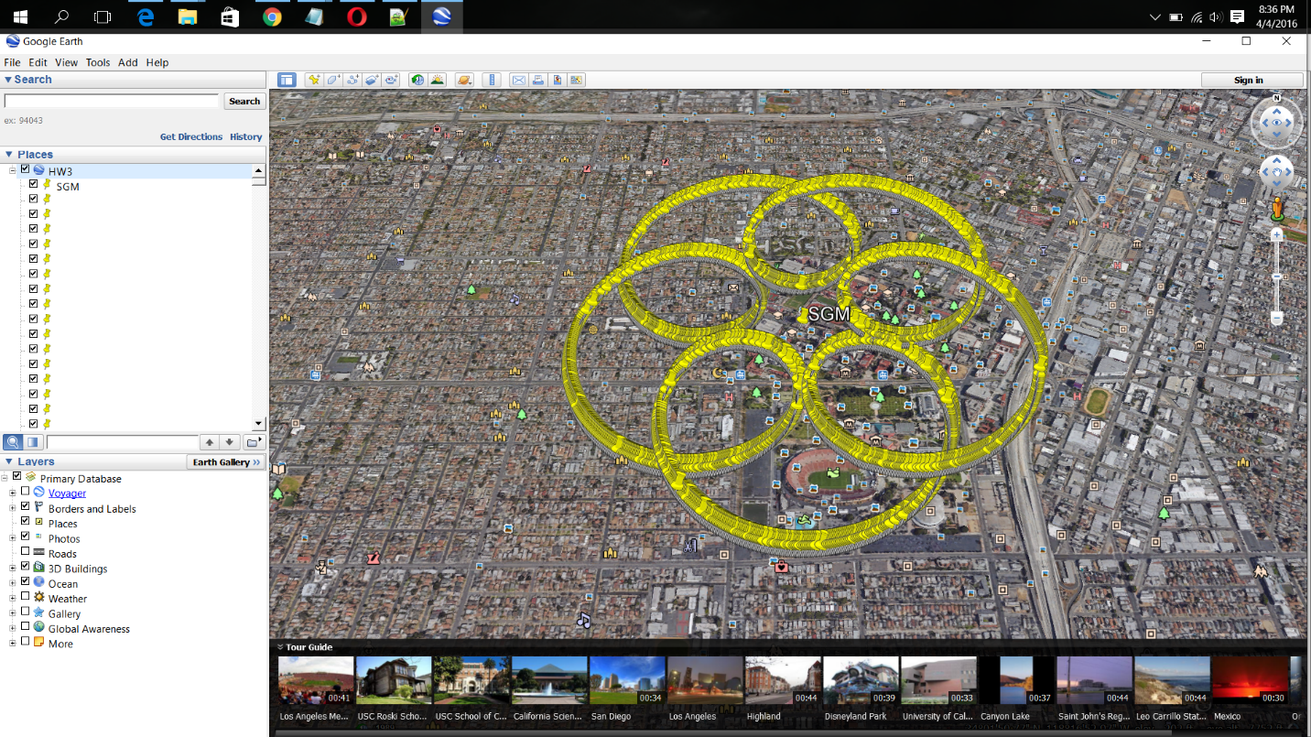

**KML for Convex Hull:**

<?xml version="1.0" encoding="utf-8"?>

<kml xmlns="http://www.opengis.net/kml/2.2">

<Document>

<name>galen</name>

<visibility>0</visibility>

<open>1</open>

<Placemark>

<name>Home</name>

<Point>

<coordinates>-118.28028610000001,34.028357,0</coordinates>

</Point>

</Placemark>

<Placemark>

<name>Galen</name>

<Point>

<coordinates>-118.27975,34.02127,0</coordinates>

</Point>

</Placemark>

<Placemark>

<name>Lyon Center</name>

<Point>

<coordinates>-118.28831,34.02439,0</coordinates>

</Point>

</Placemark>

<Placemark>

<name>SGM</name>

<Point>

<coordinates>-118.2890857,34.0210824,0</coordinates>

</Point>

</Placemark>

<Placemark>

<name>Tommy Trojan</name>

<Point>

<coordinates>-118.28599229999999,34.0206485,0</coordinates>

</Point>

</Placemark>

<Placemark>

<name>Doheny Memorial Library</name>

<Point>

<coordinates>-118.28395,34.02023,0</coordinates>

</Point>

</Placemark>

<Placemark>

<name>Leavey Library</name>

<Point>

<coordinates>-118.28297339999999,34.021642299999996,0</coordinates>

</Point>

</Placemark>

<Placemark>

<name>USC Schaeffer Center</name>

<Point>

<coordinates>-118.28355069999999,34.018926799999996,0</coordinates>

</Point>

</Placemark>

<Placemark>

<name>Ogasawara Plaza</name>

<Point>

<coordinates>-118.2908054,34.0191909,0</coordinates>

</Point>

</Placemark>

<Style id="yellowLineGreenPoly">

<LineStyle>

<color>7f00ffff</color>

<width>4</width>

</LineStyle>

<PolyStyle>

<color>7f00ff00</color>

</PolyStyle>

</Style>

<Placemark>

<name>Absolute Extruded</name>

<description>Transparent green wall with yellow outlines</description>

<styleUrl>#yellowLineGreenPoly</styleUrl>

<LineString>

<extrude>1</extrude>

<tessellate>1</tessellate>

<altitudeMode>absolute</altitudeMode>

<coordinates>

-118.28028610000001, 34.028357,200

-118.27975, 34.02127,200

-118.28355069999999, 34.018926799999996,200

-118.2908054, 34.0191909,200

-118.28831, 34.02439,200

-118.28028610000001, 34.028357,200

</coordinates>

</LineString>

</Placemark>

</Document>

</kml>

**Nearest Point KML:**

<?xml version="1.0" encoding="utf-8"?>

<kml xmlns="http://www.opengis.net/kml/2.2">

<Document>

<name>galen</name>

<visibility>0</visibility>

<open>1</open>

<Placemark>

<name>Home</name>

<Point>

<coordinates>-118.28028610000001,34.028357,0</coordinates>

</Point>

</Placemark>

<Placemark>

<name>Galen</name>

<Point>

<coordinates>-118.27975,34.02127,0</coordinates>

</Point>

</Placemark>

<Placemark>

<name>Lyon Center</name>

<Point>

<coordinates>-118.28831,34.02439,0</coordinates>

</Point>

</Placemark>

<Placemark>

<name>SGM</name>

<Point>

<coordinates>-118.2890857,34.0210824,0</coordinates>

</Point>

</Placemark>

<Placemark>

<name>Tommy Trojan</name>

<Point>

<coordinates>-118.28599229999999,34.0206485,0</coordinates>

</Point>

</Placemark>

<Placemark>

<name>Doheny Memorial Library</name>

<Point>

<coordinates>-118.28395,34.02023,0</coordinates>

</Point>

</Placemark>

<Placemark>

<name>Leavey Library</name>34.02176 -118.28276

<Point>

<coordinates>-118.28276,34.02176,0</coordinates>

</Point>

</Placemark>

<Placemark>

<name>USC Schaeffer Center</name>

<Point>

<coordinates>-118.28355069999999,34.018926799999996,0</coordinates>

</Point>

</Placemark>

<Placemark>

<name>Ogasawara Plaza</name>

<Point>

<coordinates>-118.2908054, 34.0191909, 0</coordinates>

</Point>

</Placemark>

<Style id="yellowLineGreenPoly">

<LineStyle>

<color>7f00ffff</color>

<width>4</width>

</LineStyle>

<PolyStyle>

<color>7f00ff00</color>

</PolyStyle>

</Style>

<Placemark>

<name>Absolute Extruded</name>

<description>Transparent green wall with yellow outlines</description>

<styleUrl>#yellowLineGreenPoly</styleUrl>

<LineString>

<extrude>1</extrude>

<tessellate>1</tessellate>

<altitudeMode>absolute</altitudeMode>

<coordinates>

-118.28028610000001, 34.028357,100

-118.28831, 34.02439, 100

-118.28028610000001, 34.028357, 100

-118.27975, 34.02127,100

-118.28028610000001, 34.028357,100

-118.28297339999999, 34.021642,100

</coordinates>

</LineString>

</Placemark>

</Document>

</kml>

***Spirograph HTML file:***

<html>

<head>

<meta name="viewport" content="initial-scale=1.0, user-scalable=no">

<meta charset="utf-8">

<style></style>

</head>

<body>

<script>

var sgm={lat:34.0210824,lng:-118.2890857};

var R=5,r=1,a=4;

var x0=R+r-a,y0=0;

var cos=Math.cos,sin=Math.sin,pi=Math.PI,nRev=10;

for(var t=0.0;t<(pi*nRev);t+=0.01){

var x=(R+r)*cos((r/R)*t) - a*cos((1+r/R)*t);

var y=(R+r)*sin((r/R)*t) - a*sin((1+r/R)*t);

document.writeln('&ltPlacemark&gt&ltname&gt&lt/name&gt&ltPoint&gt&ltcoordinates&gt'+(sgm["lng"]+y/1000)+','+(sgm["lat"]+x/1000)+',0'+'&lt/coordinates&gt&lt/Point&gt&lt/Placemark&gt'+'<br>');

//document.write('<Placemark><name>Home</name><Point><coordinates>'+sgm["lng"]+10*y+','+sgm["lat"]+10*x+',0</coordinates></Point></Placemark>');

}

</script>

</body>

</html>